Concise Summary of Highly Rated Application Cases for the Soft Robot Walker
Participants consistently rated the following application domains as highly important:
- Healthcare, Caregiving, and Assistive Support
The Soft Robot Walker (SRW) is seen as highly valuable for assisting elderly, disabled, or incapacitated individuals in homes, hospitals, and care facilities. Key uses include fetching and carrying items, supporting mobility and rehabilitation, handling delicate tasks, aiding nurses and surgeons, and performing gentle medical procedures or minimally invasive interventions.
- Search, Rescue, and Disaster Response
A major application area involves search-and-rescue operations in hazardous or inaccessible environments such as collapsed buildings, earthquake rubble, fires, war zones, and extreme weather conditions. Its soft, flexible body enables safe navigation over unstable terrain, entry into confined spaces, and locating or delivering aid to trapped people or animals without risking human responders.
- Dangerous and High-Risk Environments
Participants highlighted strong relevance for use in environments unsafe for humans, including bomb and landmine disposal, nuclear or highly radioactive areas, biological hazard cleanup, toxic or high-temperature zones, and deep-sea or underwater inspection. The SRW’s compliance and adaptability reduce risk when handling explosives or hazardous materials.
- Industrial, Manufacturing, and Logistics Applications
The SRW was rated highly for collaborative robotics in factories, warehouses, and construction sites—especially for handling fragile items, operating in tight spaces, assisting human workers, and performing repetitive or precision tasks on uneven or unconventional surfaces.
- Environmental, Agricultural, and Scientific Exploration
Important applications include environmental monitoring, ecological research, animal conservation and rescue, agriculture (e.g., fruit picking, planting seeds, soil and water sampling), pipeline and infrastructure inspection, and exploration of caves, mines, archaeological sites, space, or other remote natural environments.
- Domestic, Social, and Public Services
Participants also emphasized home assistance, social care, hospital logistics, cleaning and recycling tasks, street and beach cleanup, and delivery of food, medicine, or supplies—particularly for people in isolation or with limited mobility.
Overall, highly rated scenarios converge on the SRW’s softness, flexibility, safety, and terrain adaptability, making it especially suitable where humans, rigid robots, or wheeled systems are limited by risk, delicacy, or accessibility.

Concise summary of participants’ reflections on the ecological aspect of sustainability
Overall, participants linked the Soft Robot Walker (SRW) to ecological sustainability mainly through its potentially lower environmental footprint and its ability to operate gently in natural settings:
- Lower resource and energy demands (in principle): Many emphasized that the SRW’s compressed-air actuation and lack of electronics/batteries could reduce electricity use and avoid resource-intensive components (e.g., rare metals, circuit boards, lithium), potentially lowering emissions and mining impacts.
- Materials, manufacturing, and end-of-life considerations: A common theme was that 3D printing may reduce manufacturing waste (more precise material use) and enable local/on-site production, cutting transport impacts. Several also suggested the robot could be made from recycled and/or biodegradable materials, improving recyclability and reducing landfill waste—especially compared to “hard” robots.
- Minimal disruption to ecosystems in use: Participants frequently noted the SRW’s soft, lightweight, insect-like locomotion as environmentally “gentle,” enabling movement across sensitive terrain (forest floors, sand, rocks, wetlands) with less risk of damage to plants, animals, or delicate structures.
- Direct ecological applications: Many proposed using SRW for environmental monitoring (cameras/sensors for habitats and climate impacts), sampling, conservation work, and pollution cleanup (e.g., collecting waste/plastics), including in locations unsafe or inaccessible to humans.
- Caveats and skepticism: A substantial minority questioned the ecological benefit, pointing to polymers/plastics, electricity needed for 3D printing and air compression, air cartridge manufacturing, and the broader view that making “non-essential” devices still consumes resources. Several said it’s too early to judge without clearer lifecycle details (materials, sourcing, recycling systems, and actual use cases).
SDGs:
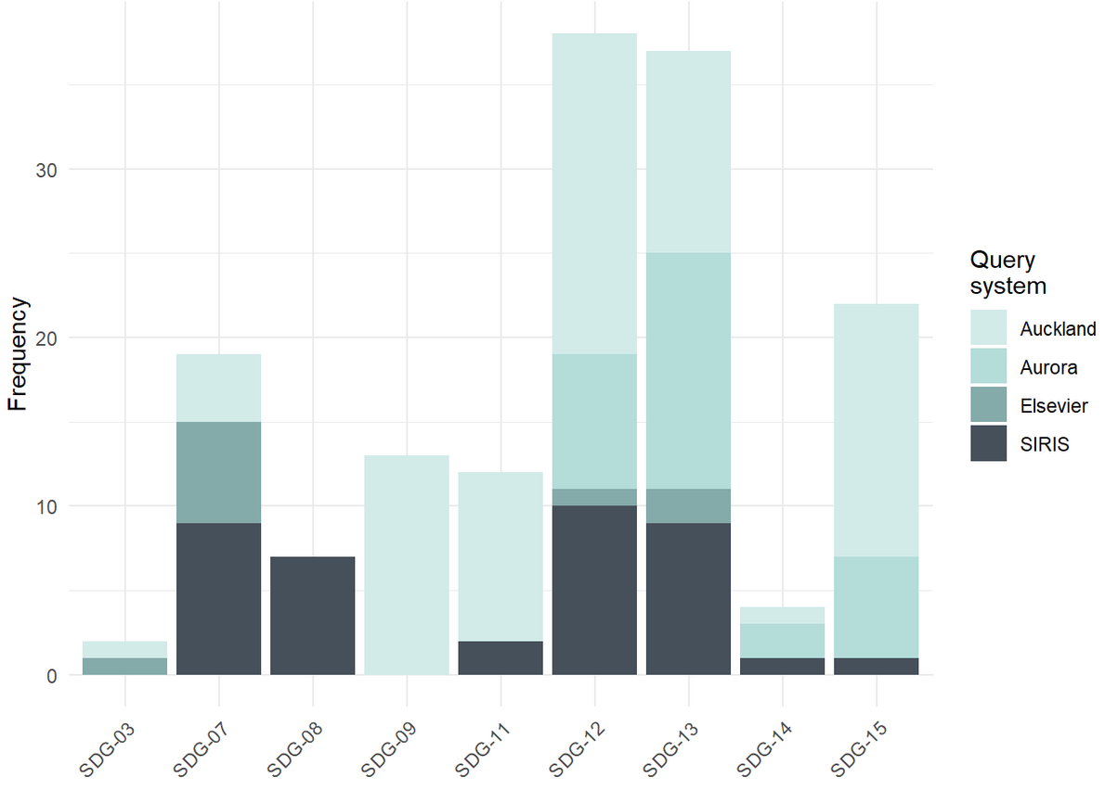
From the chart, participants most strongly associated their ecological sustainability reflections with:
- SDG 12 – Responsible Consumption & Production (highest overall)
- SDG 13 – Climate Action (close second)
A clear secondary peak is:
- SDG 15 – Life on Land
All other SDGs shown (e.g., SDG 7, 9, 11, 14, 3, 8) appear notably lower by comparison.

Concise summary of participants’ reflections on the social aspect of sustainability
Participants’ responses converged on several key social themes, alongside notable uncertainty and skepticism:
- Safety and human well-being: The most consistent point was that the Soft Robot Walker’s soft, flexible design makes it safer and less intimidating for close human interaction than rigid robots. This was seen as beneficial in healthcare, social care, education, workplaces, and disaster zones, reducing injury risk and protecting people from hazardous tasks (e.g. bomb disposal, disaster response).
- Support for vulnerable and marginalized groups: Many highlighted potential to improve quality of life and independence for elderly people, individuals with disabilities, and those with mobility limitations—by assisting with everyday tasks, caregiving, or rehabilitation—thereby promoting inclusion and dignity.
- Accessibility, affordability, and equity: Participants frequently linked social sustainability to the SRW’s low-cost materials, durability, and modular 3D-printed design. The possibility of home or local production and open-source sharing was seen as democratizing robotics, increasing access for lower-income communities, schools, and regions with limited infrastructure or electricity.
- Education, skills, and social learning: The SRW was viewed as a useful educational and inspirational tool—for teaching robotics, biology-inspired movement, and engineering—helping build skills, curiosity, and future-oriented learning across diverse populations.
- Reducing inequality and hazardous labor: Some respondents noted that transferring dangerous, dirty, or repetitive jobs to robots could reduce health risks, protect low-income or marginalized workers, and contribute to fairer labor conditions.
- Caveats and disagreement: A substantial minority struggled to see a clear link to social sustainability, viewing the SRW as “just another tool” or questioning its real-world relevance, equity of access (e.g. need for 3D printers or internet), and broader societal impact. Concerns were also raised about potential military uses or the technology not addressing deeper social problems.
Overall, participants associated the SRW’s social sustainability primarily with safety, inclusion, accessibility, and improved well-being, while remaining divided on how transformative or socially essential its impact would ultimately be.
SDGs:
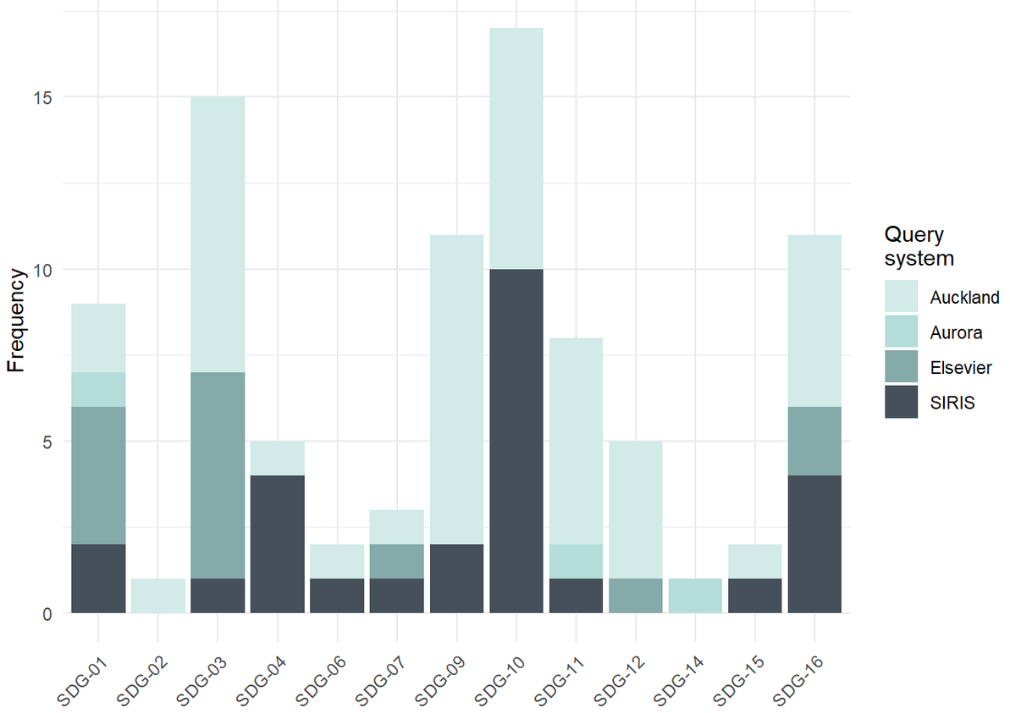
Based on the chart, participants most strongly associated their social sustainability reflections with the following Sustainable Development Goals:
- SDG 10 – Reduced Inequalities (highest overall)
- SDG 3 – Good Health and Well-Being
These were followed by a clear secondary group:
- SDG 16 – Peace, Justice and Strong Institutions
- SDG 9 – Industry, Innovation and Infrastructure
- SDG 1 – No Poverty
Lower but still present associations appeared for SDG 4 (Quality Education), SDG 11 (Sustainable Cities and Communities), and SDG 12 (Responsible Consumption and Production).
Overall, the pattern indicates that participants primarily framed the social impact of the Soft Robot Walker in terms of health and well-being, inclusion and equity, social protection, and safer societal structures, rather than education or consumption-focused goals.

Concise summary of participants’ reflections on the economic aspect of sustainability
Participants most often framed the Soft Robot Walker (SRW) as economically sustainable due to lower costs, easier production, and broader usability, with some concerns about real-world trade-offs:
- Low-cost, decentralized production: The strongest theme was that 3D printing and modular parts reduce barriers to entry, enabling cheaper manufacturing (even at home or locally), faster prototyping/iteration, and potentially lower shipping/supply-chain costs.
- Lower operating and maintenance costs: Many linked economic resilience to the SRW’s compressed-air actuation and reduced mechanical complexity (no electronics/batteries), expecting lower energy costs, less wear-and-tear, longer lifespans, and cheaper repair/part replacement.
- Productivity and new economic opportunities: Respondents frequently suggested the SRW could improve productivity across sectors (industry, healthcare, hazardous work) by doing tasks that are risky, repetitive, or difficult for humans/rigid robots—while also enabling new markets, innovation, and employment in development, manufacturing, customization, and services.
- Equity and access: Some argued that lower costs could make robotics more accessible to small businesses, schools, and lower-income regions, supporting more inclusive economic participation (e.g., enabling disabled people to work, or reducing care burdens).
- Caveats and disagreements: A notable minority were unsure or skeptical, raising points about hidden energy costs (air compression, 3D printing), plastics/polymers, unclear use cases, profit-driven commercialization, and potential job displacement if robots substitute human labor.
Overall, participants associated economic sustainability mainly with affordability, durability, and adaptability, while acknowledging uncertainty about lifecycle costs, adoption, and labor impacts.

SDGs:
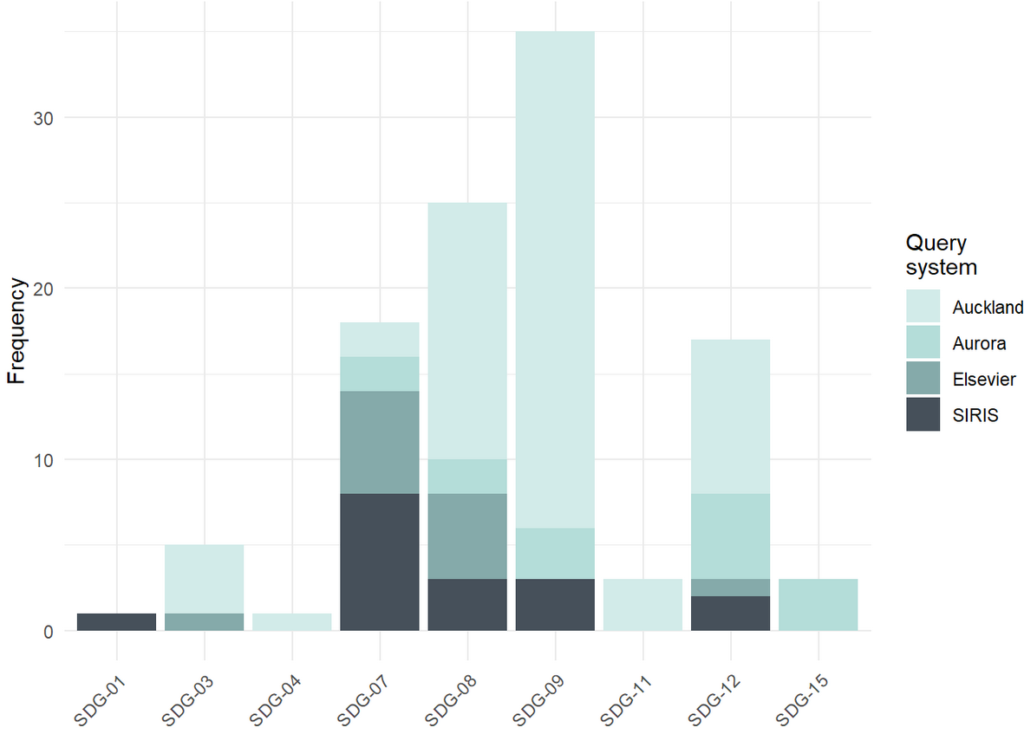
Based on the chart, participants most strongly associated their economic sustainability reflections with the following Sustainable Development Goals:
- SDG 9 – Industry, Innovation and Infrastructure (clearly the highest)
- SDG 8 – Decent Work and Economic Growth
A secondary cluster of relevance appears for:
- SDG 7 – Affordable and Clean Energy
- SDG 12 – Responsible Consumption and Production
Lower-frequency associations were observed for SDG 3 (Good Health and Well-Being), SDG 11 (Sustainable Cities and Communities), and SDG 15 (Life on Land).
Overall, the pattern indicates that participants primarily framed the economic sustainability of the Soft Robot Walker around innovation-driven growth, productivity, affordability, and reduced production and operating costs, rather than broader social or environmental economic spillovers.

